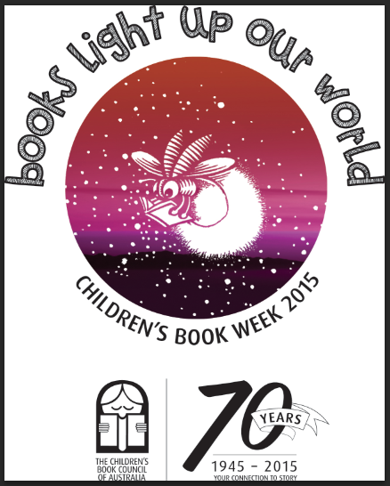

What Are

You Reading

Mr Firefly?

What is Mr Firefly reading?

Book Week 2015

I am reading about a

I am reading about a